FOR IMMEDIATE RELEASE

STRATEGIZE TO SURVIVE IN “DUNGEON ENCOUNTERS”, A NEW DUNGEON EXPLORATION RPG OUT NOW
Fans Can Save 20% on Nintendo Switch™, PlayStation®4 Console and Steam®

LONDON (14 Oct., 2021) – Square Enix Ltd., today announced that the new single-player dungeon exploration RPG, DUNGEON ENCOUNTERS™ is now available digitally for the Nintendo Switch™ system, the PlayStation®4 console and PC via Steam®. Players can save 20% on the Nintendo™ Switch, PlayStation®4* console and Steam® until late October. **
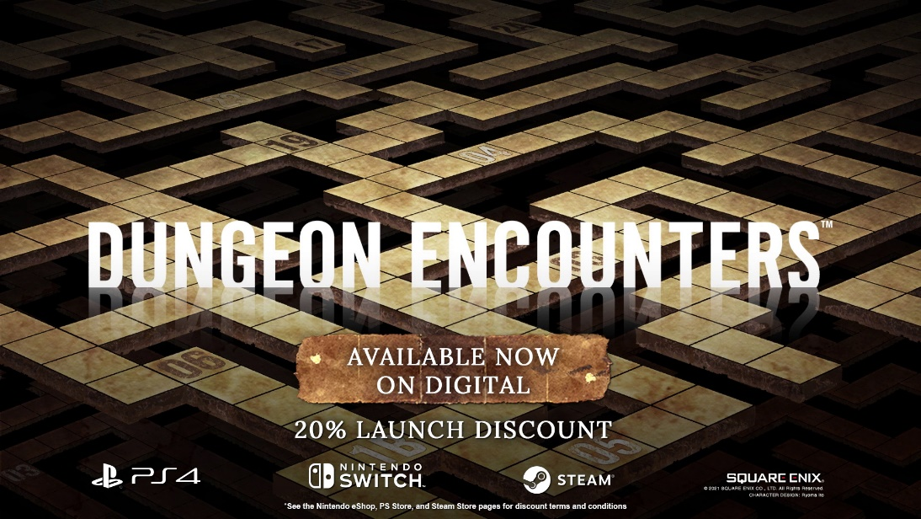
To watch the “DUNGEON ENCOUNTERS | Out Now Trailer” now, visit: https://youtu.be/bEWNcKT8CQc
DUNGEON ENCOUNTERS, directed by Ito Hiroyuki, known from the FINAL FANTASY series, and produced by Kato Hiroaki from FINAL FANTASY XII THE ZODIAC AGE, is a new dungeon exploration RPG game that focusses on a newly refined and straightforward game design. The game is based on a minimalist design philosophy, so that the players can focus on experiencing the fun gameplay mechanics.
A challenging 99 floor dungeon awaits! Move around a 2D gameboard style map as you set off on a journey to explore the depths of an otherworldly labyrinth. You will need to strategise to survive in order to overcome a myriad of perils, fierce battles and potent game mechanics to reach the deepest levels of the dungeon. The thought provoking challenges is what will make this new dungeon exploration RPG a rewarding experience for players!
DUNGEON ENCOUNTERS is rated PEGI 7 and is now available for the Nintendo Switch™ system, the PlayStation®4 console and PC via Steam®.
*20% discount offer for Nintendo Switch™ system ends on October, 21 at 11:59pm BST/CET; and for PC (via Steam®) on October, 29 at 4:59pm BST / 5:59pm CET
**20% discount offer for PlayStation Plus members on PlayStation®4 console is available until 11:59pm BST/ CET on October, 28.

For more information, visit: https://square-enix-games.com/games/dungeon-encounters
Related Links:
Official Website: https://square-enix-games.com/games/dungeon-encounters
Twitter: http://www.twitter.com/SquareEnix
Facebook: http://www.facebook.com/SquareEnix
#DungeonEncounters

About Square Enix Ltd.
Square Enix Ltd. develops, publishes, distributes and licenses SQUARE ENIX®, EIDOS® and TAITO® branded entertainment content in Europe and other PAL territories as part of the Square Enix group of companies. Square Enix Ltd. also has a global network of leading development studios such as Crystal Dynamics® and Eidos Montréal®. The Square Enix group of companies boasts a valuable portfolio of intellectual property including: FINAL FANTASY®, which has sold over 164 million units worldwide; DRAGON QUEST®, which has sold over 83 million units worldwide; TOMB RAIDER®, which has sold over 85 million units worldwide; and the legendary SPACE INVADERS®. Square Enix Ltd. is a London-based, wholly owned subsidiary of Square Enix Holdings Co., Ltd.

More information on Square Enix Ltd. can be found at https://square-enix-games.com

##

DUNGEON ENCOUNTERS, CRYSTAL DYNAMICS, DRAGON QUEST, EIDOS, EIDOS MONTREAL, FINAL FANTASY, SPACE INVADERS, SQUARE ENIX, the SQUARE ENIX logo, TAITO and TOMB RAIDER are registered trademarks or trademarks of the Square Enix group of companies “Steam” is a trademark and/or registered trademark of Valve Corporation in the U.S. and/or other countries. "PlayStation” is a registered trademark of Sony Interactive Entertainment Inc. All other trademarks are properties of their respective owners.

