**FOR IMMEDIATE RELEASE**

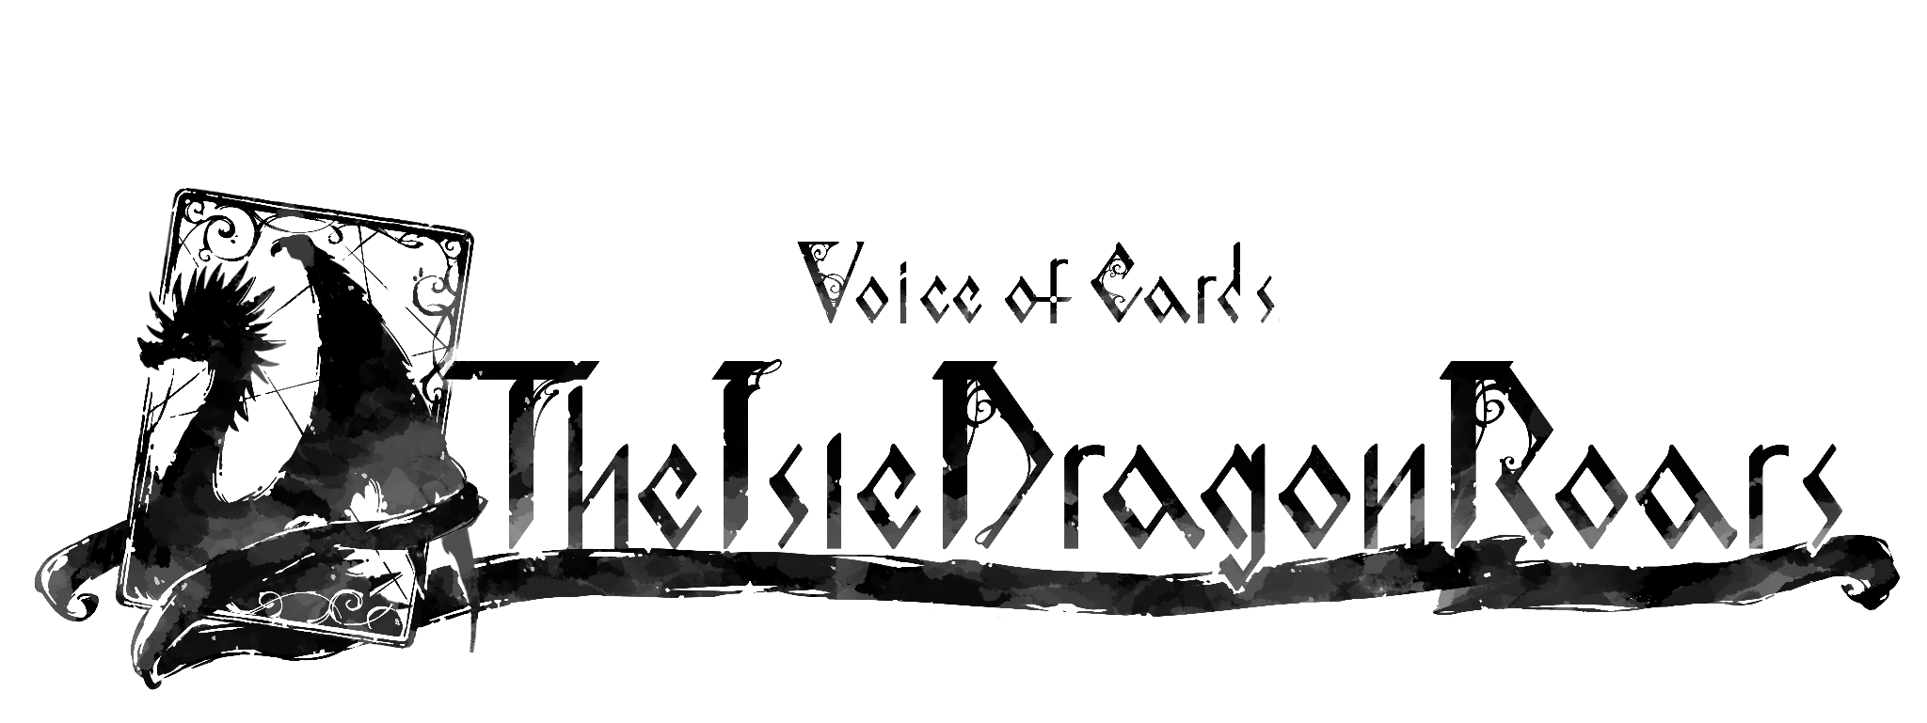

**SQUARE ENIX NEW CARD-BASED RPG**

***VOICE OF CARDS: THE ISLE DRAGON ROARS***

**TO LAUNCH ON OCTOBER 28**

*Bundle Includes The Game, Pixel Art Set DLC, And DLC Themed After*

*NieR Replicant ver.1.22474487139…*

**LONDON (Sept. 23, 2021)** – [Square Enix Ltd.,](http://eu.square-enix.com/en/change/langs) today announced that *Voice of Cards: The Isle Dragon Roars,* a unique new card-based RPG, will be available digitally for the [Nintendo Switch™](https://www.nintendo.com/games/detail/voice-of-cards-the-isle-dragon-roars-switch/) system, [PlayStation®4](https://store.playstation.com/en-gb/product/EP0082-CUSA27400_00-VOCTIDRSET000001) computer entertainment system and PC via Steam® on October 28, 2021.

Developed by the creative team behind the beloved NieR® and Drakengard® series, including Creative Director, YOKO TARO (Drakengard series, NieR series), Executive Producer, Yosuke Saito (NieR series) and Music Director, Keiichi Okabe (*Drakengard 3*, NieR series), as well as Character Designer, Kimihiko Fujisaka (Drakengard series), this new tabletop RPG will spark players’ imagination with a unique way of storytelling.

[YOUTUBE THUMBNAIL]

View the announcement trailer here: <https://youtu.be/eVk3vWIMrsw>

In *Voice of Cards: The Isle Dragon Roars*, players will venture through a story set long ago in a world shrouded in mystery, guided by the narrative voice of the Game Master (voiced in English by Todd Haberkorn). Set in a world of swords and sorcery, the game is told entirely through the medium of cards. Players will follow the protagonist as he sets off on a journey to defeat a recently reawakened Dragon, that is threatening the land and its people, in hopes of securing an immense reward. He is joined on his travels by his companions; Mar, a monster very attached to him, and Melanie, a black witch with a grudge against the Dragon. Players will need to make choices throughout the story, as well as join in turn-based field and dungeon battles that unfold on a board, in the manner of traditional tabletop RPGs.

Fans of the NieR series will also be able to enjoy theming their adventure by purchasing the special bundle set*, which includes the game, the Pixel Art Set DLC, and seven more DLCs themed after *NieR Replicant™ ver.1.22474487139…*:

* **Dress of the Bereft** – Swaps the costumes of the Protagonist, Mar and Melanie to the design of *NieR Replicant™ ver.1.22474487139…*:
* **Emil’s Pattern** – Swaps the reverse card design to a design resembling Emil’s clothing
* **Emil Avatar** – Swaps the player’s avatar to a design resembling Emil
* **Emil Dice** – Swaps the dice to a design adorned with Emil’s face
* **Grimoire Weiss Board** – Swaps the battle board and accessories to designs patterned after Grimoire Weiss
* **Library Desk** – Swaps the table design to resemble a certain library’s stonework
* **Devola’s Music** – Swaps the general background music to a soundtrack that brings to mind the journeys of a certain young man who fought to save his sister.
* **Pixel Art Set** – Swaps all character and enemy illustrations to pixel art

*\*The items sold in this set will be available for individual purchase after the game releases.*

Fans who pre-order the game will receive the “Golden Dragon Pattern” DLC, which swaps the reverse card design to an original design by Kimihiko Fujisaka as well as a “Traditional Avatar”, which allows them to change the design of the game piece on the field into a traditional craftwork.

Players eager to learn more about the world of *Voice of Cards: The Isle Dragon Roars* can also now download a free demo, which covers events prior to the beginning of the game, on [Nintendo eShop](https://www.nintendo.com/games/detail/voice-of-cards-the-isle-dragon-roars-switch/) and the [PlayStation™ Store](https://store.playstation.com/en-gb/product/EP0082-CUSA27403_00-VOCTIDRD00000001). The demo will also be available on Steam from 5pm BST, Friday 24th September. This prologue episode reveals what happened on the day before the events of *Voice of Cards*: *The Isle Dragon Roars*, following the Ivory Order as they search for a stolen royal treasure.

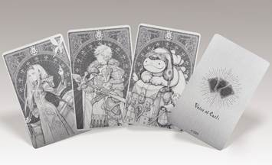

Fans can also now pre-order the physical “*Voice of Cards: The Isle Dragon Roars* Metal Card Set,” available specially on the [SQUARE ENIX Online Store](https://store.eu.square-enix-games.com/en_EU). Shipping in December 2021, this set of three metal cards, otherwise only offered as a part of the Collector’s Edition release in Japan, features the main characters from the game: Protagonist, Mar, and Melanie.

*Voice of Cards: The Isle Dragon Roars* will be available digitally for the Nintendo Switch™ system, PlayStation®4 computer entertainment system and PC via Steam® on October 28, 2021 and is rated PEGI 7.

For more information on the game, visit: <https://voiceofcards.square-enix-games.com/>

Assets are available on the press site at: <https://press.uk.square-enix.com/Voice-of-Cards-The-Isle-Dragon-Roars>

**Related Links:**

**Official Website:** <https://voiceofcards.square-enix-games.com/>

**SQUARE ENIX Twitter:** <http://www.twitter.com/SquareEnix>

**SQUARE ENIX Facebook:** <http://www.facebook.com/SquareEnix>

#VoiceOfCards

***About Square Enix Ltd.***

Square Enix Ltd. develops, publishes, distributes and licenses SQUARE ENIX®, EIDOS® and TAITO® branded entertainment content in Europe and other PAL territories as part of the Square Enix group of companies. Square Enix Ltd. also has a global network of leading development studios such as Crystal Dynamics® and Eidos Montréal®. The Square Enix group of companies boasts a valuable portfolio of intellectual property including: FINAL FANTASY, which has sold over 163 million units worldwide; DRAGON QUEST®, which has sold over 83 million units worldwide; TOMB RAIDER®, which has sold over 84 million units worldwide; and the legendary SPACE INVADERS®. Square Enix Ltd. is a London-based, wholly owned subsidiary of Square Enix Holdings Co., Ltd.

More information on Square Enix Ltd. can be found at <https://square-enix-games.com>.

# # #

Voice of Cards: The Isle Dragon Roars © 2021 SQUARE ENIX CO., LTD. All Rights Reserved.

DRAKENGARD, DRAGON QUEST, EIDOS, EIDOS MONTREAL, FINAL FANTASY, NIER, SPACE INVADERS, SQUARE ENIX, the SQUARE ENIX logo, TAITO and TOMB RAIDER are registered trademarks or trademarks of the Square Enix group of companies. Nintendo Switch is a trademark of Nintendo. Steam is a registered trademark of Valve Corporation. "PlayStation” is a registered trademark of Sony Interactive Entertainment Inc. All other trademarks are properties of their respective owners.