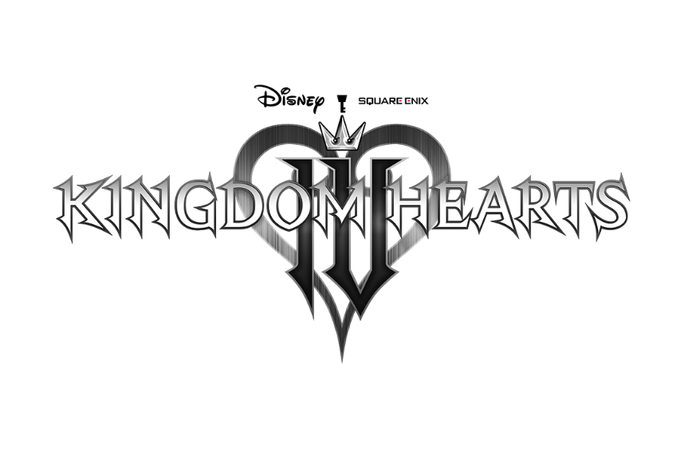
SQUARE ENIX AND DISNEY ANNOUNCE DEVELOPMENT OF KINGDOM HEARTS IV
20th Anniversary Event Unveils Next Entry in the Award-Winning Game Series that Kicks Off the “Lost Master Arc” in addition to a Brand-New Mobile Game

TOKYO, JAPAN (April 10, 2022) – Today, as part of the 20th anniversary celebration of the KINGDOM HEARTS franchise, SQUARE ENIX® and Disney announced that KINGDOM HEARTS IV, the newest installment in the beloved RPG series, is in early development, and also revealed a brand-new mobile game, KINGDOM HEARTS Missing-Link.
Watch the KINGDOM HEARTS 20th Anniversary Announcement Trailer here: https://youtu.be/j2DSEkYFRh8
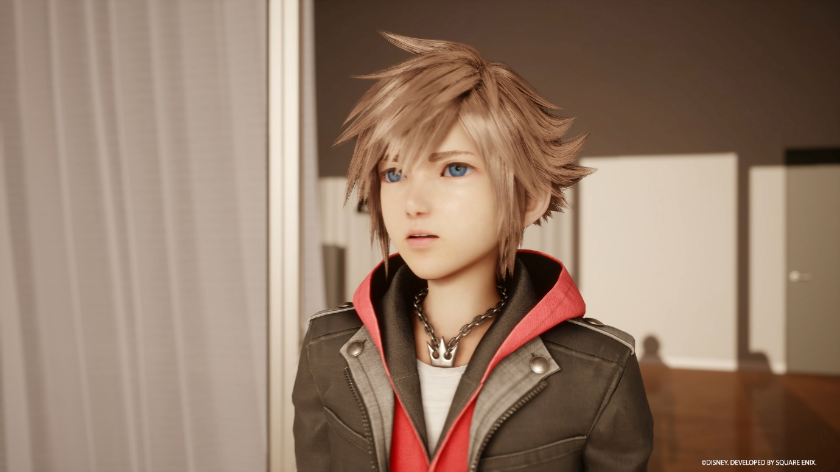
In the announcement trailer, Sora makes a triumphant return with an updated look at the beginning of an epic new storyline titled the “Lost Master Arc.” Beginning with Sora facing off in a boss battle against a giant enemy, players are introduced to the Quadratum, a large, expansive city set in a gorgeous, realistic world unlike anything ever seen before in the KINGDOM HEARTS series. Fans will be excited to see the return of Sora’s well-known companions Donald and Goofy, in addition to the first appearance of Strelitzia, a mysterious new character who appears before Sora in this strange new setting.
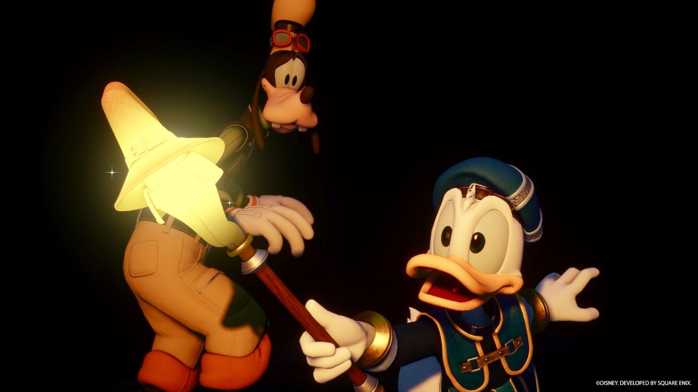

Fans can also look forward to KINGDOM HEARTS Missing-Link, an all-new game for iOS and Android devices, which allows players to embark on adventures from the realm of Scala ad Caelum into the real world. Players will be able to engage in exhilarating battles against the Heartless and discover a new, original story. A closed beta test is planned for 2022*.
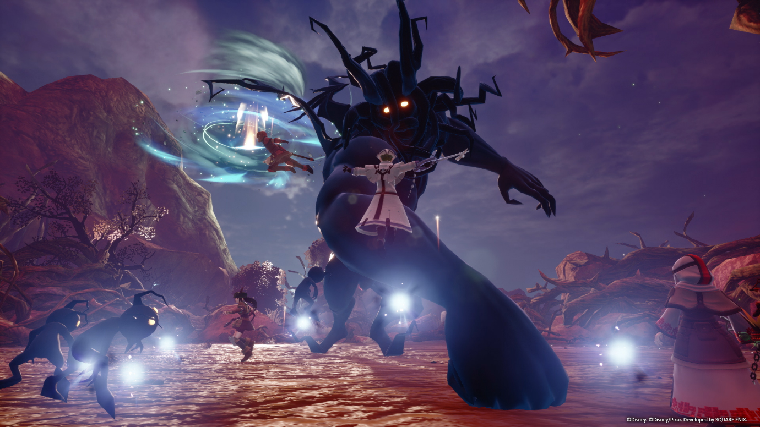

“We’re thrilled to celebrate the series’ 20th anniversary with the announcement of two new KINGDOM HEARTS titles,” said KINGDOM HEARTS series Brand Manager, Ichiro Hazama. “We’d like to thank the fans for all of their support over the years, and we can’t wait for them to experience all that’s to come for Sora.”

“Sora is an original Disney video game hero like no other, beloved by our team, and fans across the world. We’ve been honored to work with Tetsuya Nomura and his team for two decades to introduce these original stories of discovery, courage, and friendship,” said Nana Gadd, Director, Walt Disney Games. “This glimpse into Sora’s next adventure is just the beginning – we can’t wait to show more when the time is right.”

Additionally, the KINGDOM HEARTS team announced that the highly anticipated final chapter of KINGDOM HEARTS DARK ROAD will be released in August 2022 as a free update to the KINGDOM HEARTS Union χ Dark Road app.

SQUARE ENIX and Disney hosted the KINGDOM HEARTS 20th Anniversary event in Tokyo, Japan where together with fans, they celebrated the past 20 years of the beloved franchise and provided a first look at what’s to come next. The event also featured a live music performance, a showcase of stained-glass artworks and an on-stage appearance from Series Director, Tetsuya Nomura, series’ composer, Yoko Shimomura and other development members. Fans can enjoy photos from the event on the official social channels and look forward to a recording of the event which will be shared at a later date.

Lastly, there is a variety of anniversary themed merchandise available for Pre-Order through the official SQUARE ENIX Store. For more information, please visit: https://sqex.link/5n9x

For the latest assets and news, visit: https://press.square-enix.com/

Related Links:
Official Website: www.kingdomhearts.com
Twitter: @KingdomHearts
Facebook: @KingdomHearts
YouTube: https://www.youtube.com/KingdomHearts
Instagram: @KingdomHearts
#KingdomHearts

* Closed beta test will be limited to specific regions.

About the KINGDOM HEARTS Series
KINGDOM HEARTS is a series of role-playing games created through the collaboration of Disney and Square Enix. Since the first KINGDOM HEARTS was released in March 2002 for the PlayStation®2 computer entertainment system, the series has expanded with several additional entries. The series is celebrating its 20th anniversary this year and has shipped over 35 million units worldwide. Since the launch of KINGDOM HEARTS III in 2019, the critically acclaimed RPG has shipped more than five million units globally, both physically and digitally, making it the fastest selling game in the history of the series. KINGDOM HEARTS IV, the next mainline entry in the series, is currently in development for console devices.

About Square Enix Ltd.
Square Enix Ltd. develops, publishes, distributes and licenses SQUARE ENIX®, EIDOS® and TAITO® branded entertainment content in Europe and other PAL territories as part of the Square Enix group of companies. Square Enix Ltd. also has a global network of leading development studios such as Crystal Dynamics® and Eidos Montréal®. The Square Enix group of companies boasts a valuable portfolio of intellectual property including: FINAL FANTASY®, which has sold over 164 million units worldwide; DRAGON QUEST®, which has sold over 83 million units worldwide; TOMB RAIDER®, which has sold over 85 million units worldwide; and the legendary SPACE INVADERS®. Square Enix Ltd. is a London-based, wholly owned subsidiary of Square Enix Holdings Co., Ltd.

More information on Square Enix Ltd. can be found at https://square-enix-games.com.

# # #

© Disney. © Disney/Pixar.
Developed by SQUARE ENIX.
CRYSTAL DYNAMICS, DRAGON QUEST, EIDOS, EIDOS MONTREAL, FINAL FANTASY, SPACE INVADERS, SQUARE ENIX, the SQUARE ENIX logo, TAITO and TOMB RAIDER are registered trademarks or trademarks of the Square Enix group of companies. All other trademarks are properties of their respective owners.

