FOR IMMEDIATE RELEASE
SQUARE ENIX COLLECTIVE ANNOUNCES FAIRYTALE HORROR LITTLE GOODY TWO SHOES

The Secret is Out of the Woods
LONDON (AUGUST 17, 2022) – Square Enix Collective® is excited to announce Little Goody Two Shoes™, a mysterious new fairytale anime adventure with a dark twist. The narrative-focused horror role-playing game is being developed by AstralShift, an independent game development team based in Portugal and dedicated to creating stunning cinematic and narrative games with immersive storylines and evoking soundtracks.
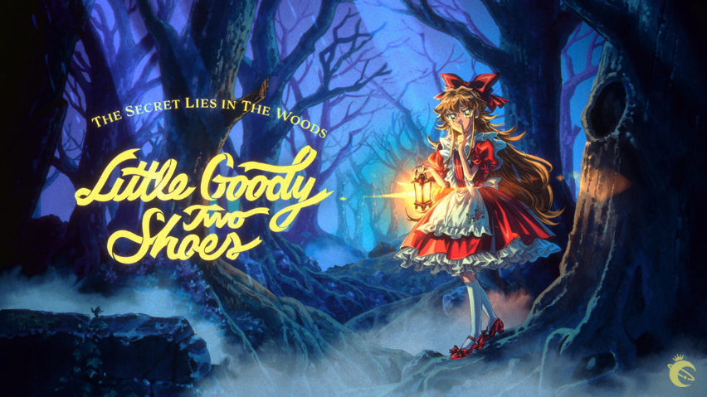
Set in the mysterious Kieferberg Village, Little Goody Two Shoes™ is a homage to the original PlayStation® and early PlayStation®2 (PS2) RPGs and is centered around Elise, an ambitious girl determined to become rich and escape her humble life. Players will step into Elise’s shoes and soon find themselves immersed in a 90's inspired horror role-playing adventure game. Gameplay elements such as ‘Sustenance’, ‘Reputation & Suspicion’ and ‘Exploration & Narrative’ will guide players to complete their daily tasks by day and uncover the woodland’s darkest secrets by night. Players will also have the ability to set their own paths to navigate through the wicked woods, solve puzzles and build meaningful relationships in this nostalgic gaming experience.
“We couldn’t be more excited to be working alongside Square Enix Collective for this project,” said Patrícia Silva, CEO of AstralShift, on behalf of the team. “Square Enix is a company that we greatly respect and titles such as Legend of Mana have been a big source of inspiration for us along the development process. It’s a true honour to have them at our side.”
“We’re delighted to be working with AstralShift - we were blown away by the early work the team had put into the project, and we can’t wait to show more as we head towards release next year,” commented Phil Elliott, studio head at Square Enix Collective®.

To learn more about the game, please join the discussion on Discord and follow the AstralShift and Square Enix Collective® Social Media Channels. Elise will soon be in touch with more news!
Press contact Square Enix Collective: collective-pr@eu.square-enix.com
Related Links:
Twitter: twitter.com/AstralShiftPro
Discord: discord.gg/MbzgqsAtE8
Instagram: instagram.com/astralshiftpro

About AstralShift
AstralShiftPro LDA is an independent video game software development company based in Portugal. Officially founded in 2022, AstralShiftPro’s story started in 2016 with the release of the popular RPG maker title Pocket Mirror. With video games as its medium, AstralShiftPro specializes in the production of narrative-driven and artistically ambitious titles, with the goal to create immersive and unforgettable experiences.

About Square Enix Collective®
Square Enix Collective® is a London-based division of Square Enix Ltd. The Square Enix Collective® programme was launched in 2014 to assist indie game developers build community awareness for hundreds of game pitches and has helped teams raise in excess of $1.2 million via Kickstarter campaigns. Square Enix Collective® has now published and distributed a range of indie titles since April 2016 and is on the look-out for great new projects and talented teams to work with globally – whether it’s publishing support for a development that’s already funded, or investment to help the creation of a game.

About Square Enix Ltd.
Square Enix Ltd. develops, publishes, distributes and licenses SQUARE ENIX®, EIDOS® and TAITO® branded entertainment content in Europe and other PAL territories as part of the Square Enix group of companies. Square Enix Ltd. also has a global network of leading development studios such as Crystal Dynamics® and Eidos Montréal®. The Square Enix group of companies boasts a valuable portfolio of intellectual property including: FINAL FANTASY, which has sold over 168 million units worldwide; DRAGON QUEST®, which has sold over 84 million units worldwide; TOMB RAIDER®, which has sold over 88 million units worldwide; and the legendary SPACE INVADERS®. Square Enix Ltd. is a London-based, wholly owned subsidiary of Square Enix Holdings Co., Ltd.
More information on Square Enix Ltd. can be found at https://square-enix-games.com

# # #

CRYSTAL DYNAMICS, DRAGON QUEST, EIDOS, FINAL FANTASY, SPACE INVADERS, SQUARE ENIX, the SQUARE ENIX logo, SQUARE ENIX COLLECTIVE, the SQUARE ENIX COLLECTIVE logo, TAITO and TOMB RAIDER are registered trademarks or trademarks of the Square Enix group of companies.

“Steam” is a trademark and/or registered trademark of Valve Corporation in the U.S. and/or other countries. "PlayStation”, “PS4” and “PS5” are trademarks and/or registered trademarks of Sony Interactive Entertainment Inc.

All other trademarks are properties of their respective owners.

