FOR IMMEDIATE RELEASE
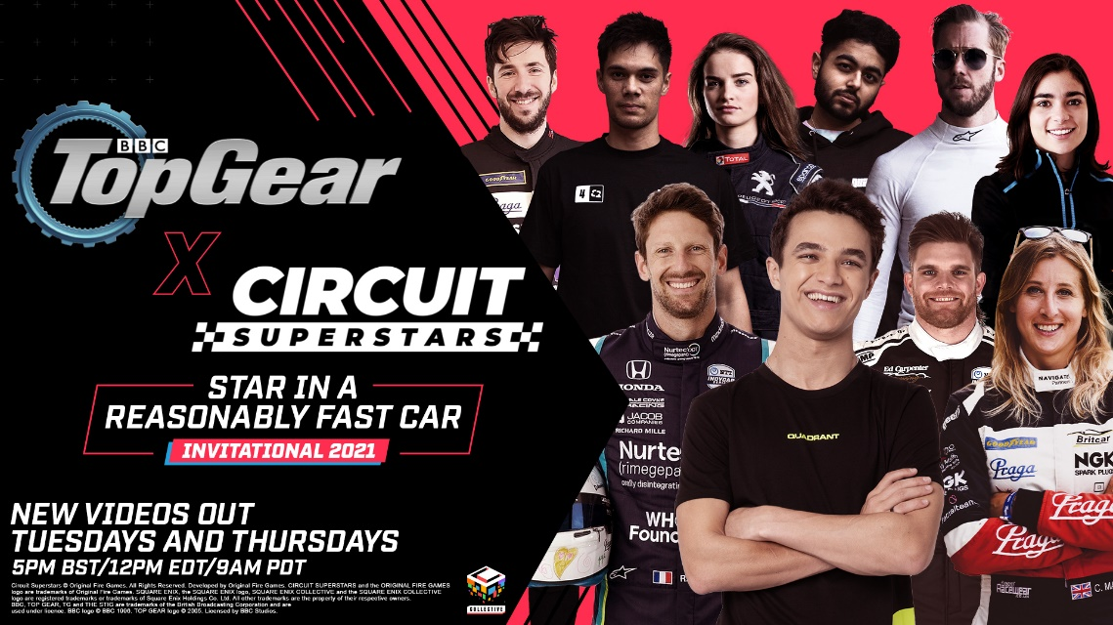
SQUARE ENIX COLLECTIVE ANNOUNCE CIRCUIT SUPERSTARS PARTNERSHIP WITH BBC TOP GEAR
Lando Norris and Romain Grosjean revealed among star-studded line-up for Circuit Superstars’ unique take on the “Star in a Reasonably Fast Car” feature

LONDON ( 7th September, 2021) – SQUARE ENIX® Ltd., and Original Fire Games have partnered with BBC Studios and Top Gear for upcoming racing game CIRCUIT SUPERSTARS. The collaboration is kicking off with a special online version of the show’s “Star in a Reasonably Fast Car” feature! The fun-fuelled video series will release on 9th September, featuring a top-tier line up of motorsport, esports and YouTube stars who will be taking on CIRCUIT SUPERSTARS’ version of the Top Gear ‘Test Track’.
Among the first participants to be revealed from the full list, which includes luminaries from across the motorsports and esports worlds, are IndyCar and former FORMULA 1 driver Romain Grosjean and FORMULA 1 star Lando Norris, alongside teammates from his Quadrant esport team.
“Like every racing fan, I have always wanted to drive the Top Gear test track, and Circuit Superstars is making that a reality. The competition will be tough, with top drivers from a variety of championships and with just one chance to set the perfect hot lap, it will be exciting to see who comes out on top.”- said Romain Grosjean.
Competitors will race their way to the top of the iconic leader board to be crowned champion of the ever so catchy title: “BBC Top Gear x Circuit Superstars Star in a Reasonably Fast Car Invitational 2021”… or “BBCTGxCSSIARFCI2021” for short.
Commentary for both the practice sessions and the hot laps will be hosted by Jack Nicholls, the unmistakable voice of motorsport. Nicholls can be heard lending his voice to BBC Radio 5 Live, FORMULA 1, and Formula E, as well as the Netflix series FORMULA 1: Drive to Survive.
“I’m so looking forward to seeing how our drivers get on,” Nicholls remarks while offering some further insight into CIRCUIT SUPERSTARS. “Make no mistake, this game looks cute, but with a very short circuit and a top-down view, our competitors will find it fiendishly difficult to hook up the perfect lap. The competition will be fierce!”
The Top Gear Test Track will be included within CIRCUIT SUPERSTARS when the game fully launches later this year – players will be able to see if they have what it takes to beat the star-studded line up!
After launch, CIRCUIT SUPERSTARS is set to release additional specially-developed Top Gear content – stay tuned for more details!
Head of Square Enix Collective, Phil Elliott, describes the Top Gear partnership and “Star in a Reasonably Fast Car” feature as the embodiment of the CIRCIT SUPERSTARS spirit. “That combination of a love for driving, fun with friends and family, and searching for the perfect lap, fits perfectly with what we hope to bring to our players around the world. What better way to launch this collaboration than by handing the keys over to some of the best drivers in the world and letting them loose on track.”
Jonathan Williams, Director of Commercial Brand Development at BBC Studios says: “Top Gear is all about mates, motors and mucking about, all of which are captured and celebrated in Circuit Superstars making this a perfect partnership”. “The love and detail that has gone into Circuit Superstars was clear to see the first time we picked up a controller and had a spin, now we can’t wait for players to take on the Top Gear Test Track and set some fast times!”.
CIRCUIT SUPERSTARS, which entered Steam’s Early Access in March of this year, has been building up its paddock of racers and fans around the world, as the development team at Original Fire Games, based in Vancouver, have focused on ensuring stability and polish gearing up for the game’s multi-platform release later this year.
CIRCUIT SUPERSTARS will be available for PC, Xbox, PlayStation in 2021 and is currently available on Steam Early Access. For more information, visit: https://store.steampowered.com/app/1097130/Circuit_Superstars/
Related Links:
Early Access on Steam: https://store.steampowered.com/app/1097130/Circuit_Superstars/
Twitter: https://twitter.com/circuitsup
Facebook: https://www.facebook.com/CircuitSUP/
YouTube: https://www.youtube.com/user/SquareEnixCollective
Instagram: https://www.instagram.com/circuitsuperstars
#TopGear #CSupInvitational

About Original Fire Games
Original Fire Games is a small team originally started by three siblings from Mexico: Carolina, Carlos and Alberto Mastretta. Together they have a combined total of 14 years in game development, as well as more than 15 accumulated years of real motor racing experience. They are bringing every bit of that expertise and passion to Circuit Superstars to make a competitive game with a charming edge. Circuit Superstars is a love letter to the world of motorsport – made for the fans, by the fans.
About Square Enix Collective
Square Enix Collective® is a London-based division of Square Enix Ltd. The Collective programme was launched in 2014 to assist indie game developers build community awareness for hundreds of games pitches and has helped teams to raise in excess of $1.2 million via Kickstarter campaigns. Collective has now published and distributed a range of indie titles since April 2016 and is on the look-out for great new projects and talented teams to work with globally – whether it’s publishing support for a development that’s already funded, or investment to help the creation of a game.
About Square Enix Ltd.
Square Enix Ltd. develops, publishes, distributes and licenses SQUARE ENIX®, EIDOS® and TAITO® branded entertainment content in Europe and other PAL territories as part of the Square Enix group of companies. Square Enix Ltd. also has a global network of leading development studios such as Crystal Dynamics® and Eidos Montréal®. The Square Enix group of companies boasts a valuable portfolio of intellectual property including: FINAL FANTASY, which has sold over 161 million units worldwide; DRAGON QUEST®, which has sold over 82 million units worldwide; TOMB RAIDER®, which has sold over 82 million units worldwide; and the legendary SPACE INVADERS®. Square Enix Ltd. is a London-based, wholly owned subsidiary of Square Enix Holdings Co., Ltd.

More information on Square Enix Ltd. can be found at https://square-enix-games.com.

About BBC Studios
BBC Studios, a global content company with bold British creativity at its heart, is a commercial subsidiary of the BBC Group, supporting the licence fee and enhancing programmes for UK audiences. Able to take an idea seamlessly from thought to screen and beyond, its activities span content financing, development, production, sales, branded services, and ancillaries across both its own productions, and programmes and formats made by high-quality UK independents. Award-winning British programmes made by the business are internationally recognised across a broad range of genres and specialisms, with brands like Strictly Come Dancing/Dancing with the Stars, Top Gear, Doctor Who and Bluey. BBC Studios has offices in over 20 markets globally, including ten production bases in the UK and production bases or partnerships in a further nine countries around the world. The company, which ordinarily makes around 2000 hours of content a year for both the BBC and third parties including Apple, Netflix and Migu, is a champion for British creativity around the world. It is also a committed partner for the UK’s independent sector through a mix of equity partnerships, content investment and international distribution for programme titles.
BBC Studios | Website | Press Office | Twitter | LinkedIn | Instagram |

##
CRYSTAL DYNAMICS, DRAGON QUEST, EIDOS, EIDOS MONTREAL, FINAL FANTASY, SPACE INVADERS, SQUARE ENIX, the SQUARE ENIX logo, TAITO and TOMB RAIDER are registered trademarks or trademarks of the Square Enix group of companies. All other trademarks are properties of their respective owners.
Circuit Superstars © Original Fire Games. All rights reserved. Developed by Original Fire Games. Published by Square Enix Limited. CIRCUIT SUPERSTARS and the ORIGINAL FIRE GAMES logo are trademarks of Original Fire Games.
BBC, TOP GEAR, TG and THE STIG are trade marks of the British Broadcasting Corporation and are used under licence. BBC logo © BBC 1996. TOP GEAR logo © 2005. Licensed by BBC Studios.

