FOR IMMEDIATE RELEASE

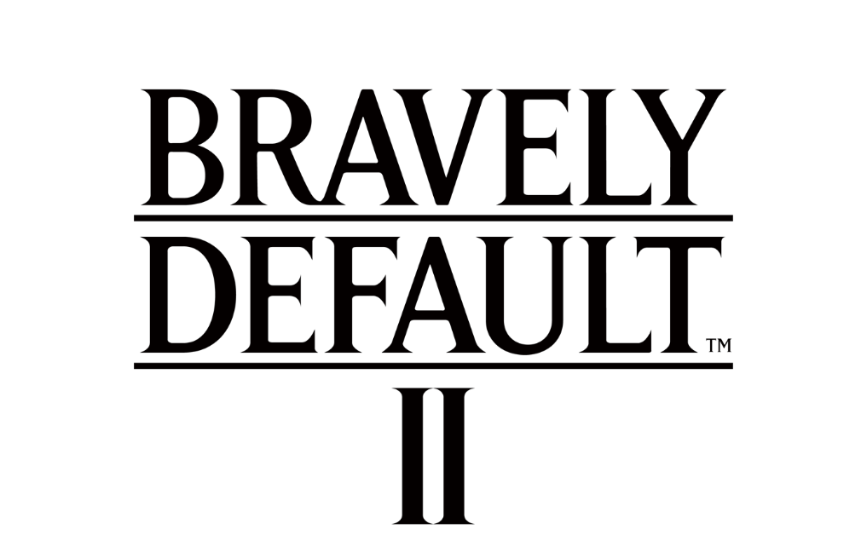

EMBARK ON A GRAND ADVENTURE WITH
BRAVELY DEFAULT II ON STEAM NEXT WEEK

Save 10% by Pre-Purchasing, Now Until September 13

LONDON (Aug. 26, 2021) – SQUARE ENIX® today announced that the critically-acclaimed RPG BRAVELY DEFAULT™ II will make its debut on PC via STEAM® on September 2, 2021. Fans can save 10% on the game by purchasing it through STEAM now until September 13, 2021. Previously available on Nintendo Switch™ system, BRAVELY DEFAULT II follows the adventures of four unlikely heroes, Seth, Gloria, Elvis, and Adelle, as they set out across the land of Excillant in search of four elemental crystals.
To watch the “BRAVELY DEFAULT II | Steam Trailer” now, visit: https://youtu.be/4zJXAXuNzys
PC gamers and newcomers alike can soon discover the thrilling Brave and Default systems of BRAVELY DEFAULT II on STEAM, where great risk can lead to even greater rewards in the game’s turn-based battles. Players can enjoy customising their party using the job system to find the optimal composition to take down challenging bosses. BRAVELY DEFAULT II features music from Revo, who makes his return from the original BRAVELY DEFAULT, and an original storyline featuring four new Heroes of Light. Full of exploration, charm, and strategy, the STEAM version of BRAVELY DEFAULT II also features controller support and various resolution options.
BRAVELY DEFAULT II is rated PEGI 12 and will be available for PC (STEAM) on September 2, 2021 with English and Japanese audio, and English, French, Italian, German, Spanish, Japanese, Korean, Simplified Chinese and Traditional Chinese text. For more information, visit: https://square-enix-games.com/games/bravely-default-ii
Related Links:
Official Facebook: www.facebook.com/squareenix
Official Twitter: @squareenix
Official YouTube: http://www.youtube.com/SquareEnixNA
Official Instagram: @squareenix
#BravelyDefault

About Square Enix Ltd.
Square Enix Ltd. develops, publishes, distributes and licenses SQUARE ENIX®, EIDOS® and TAITO® branded entertainment content in Europe and other PAL territories as part of the Square Enix group of companies. Square Enix Ltd. also has a global network of leading development studios such as Crystal Dynamics® and Eidos Montréal®. The Square Enix group of companies boasts a valuable portfolio of intellectual property including: FINAL FANTASY®, which has sold over 163 million units worldwide; DRAGON QUEST®, which has sold over 83 million units worldwide; TOMB RAIDER®, which has sold over 84 million units worldwide; and the legendary SPACE INVADERS®. Square Enix Ltd. is a London-based, wholly owned subsidiary of Square Enix Holdings Co., Ltd.

More information on Square Enix Ltd. can be found at https://square-enix-games.com

# # #

© 2021 SQUARE ENIX CO., LTD. All Rights Reserved.

BRAVELY DEFAULT, FINAL FANTASY, CRYSTAL DYNAMICS, DRAGON QUEST, EIDOS, EIDOS MONTREAL, SPACE INVADERS, SQUARE ENIX, the SQUARE ENIX logo, TAITO and TOMB RAIDER are trademarks or registered trademarks of the Square Enix group of companies. Steam is a registered trademark of Valve Corporation. Nintendo Switch is a trademark of Nintendo. All other trademarks are the properties of their respective owners.

