FOR IMMEDIATE RELEASE
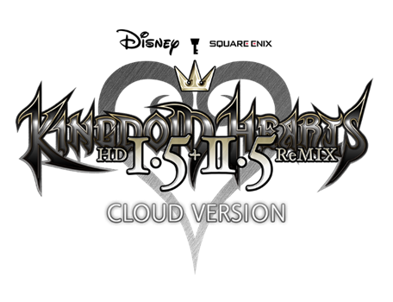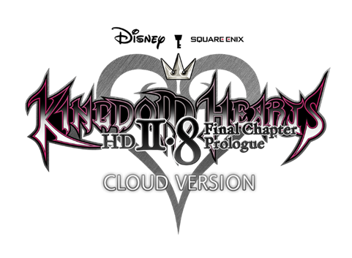
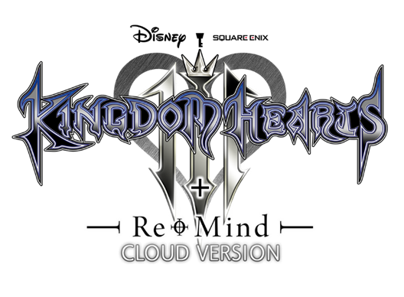
SQUARE ENIX AND DISNEY ANNOUNCE BELOVED KINGDOM HEARTS COLLECTIONS COMING TO NINTENDO SWITCH VIA CLOUD

Final Chapter in KINGDOM HEARTS DARK ROAD Mobile Game Launching this Winter

LONDON (5th October, 2021) – In the lead up to the 20th anniversary of KINGDOM HEARTS in 2022, SQUARE ENIX® and Disney today announced that cloud versions of the 10 magical KINGDOM HEARTS titles will make their long-awaited debut on Nintendo Switch as three standalone cloud releases. The streaming versions of KINGDOM HEARTS, the best-selling action RPG series will be available to purchase individually and as the all-in-one KINGDOM HEARTS INTEGRUM MASTERPIECE for Cloud collection.

The notable KINGDOM HEARTS franchise was first released in 2002 by SQUARE ENIX, and led by legendary game director Tetsuya Nomura, thus launching the longstanding collaboration between SQUARE ENIX and Disney. Since then, over 35 million copies have shipped worldwide. Nintendo Switch players, who have eagerly awaited the arrival of the series’ back catalogue on the platform will be able to join Sora, Donald, Goofy, and many other Disney characters on adventures through the “Dark Seeker Saga,” spanning from the original KINGDOM HEARTS to the critically acclaimed KINGDOM HEARTS III + Re Mind (DLC).

A full list of cloud version KINGDOM HEARTS titles coming to the Nintendo Switch can be found here: https://square-enix-games.com/en_GB/news/kingdom-hearts-switch

Additionally, the entire story of the popular mobile title, KINGDOM HEARTS Union χ [Cross], is available for players to relive or experience for the first time in theater mode through the offline version of the app. The final chapter of the spinoff story, KINGDOM HEARTS DARK ROAD, will also be released this winter. The KINGDOM HEARTS Uχ Dark Road app has surpassed 10 million downloads, and soon players around the world can look forward to experiencing the long-awaited conclusion to this prequel story.

It was also announced today that a KINGDOM HEARTS 20th Anniversary Event will be held, with further details to follow. Fans also got a first look at new 20th Anniversary merchandise items coming in 2022.

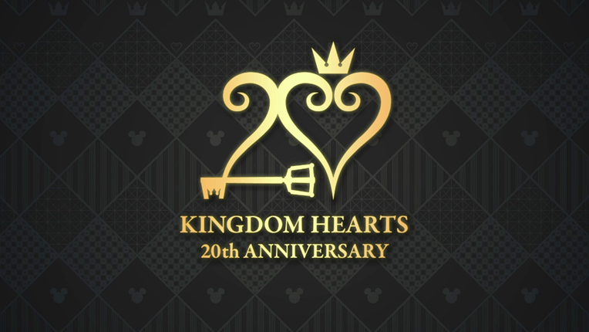

To view the KINGDOM HEARTS 20th Anniversary Announce Trailer, recapping all of the announcements made today, visit here: https://youtu.be/tivlrT6TSHA

The KINGDOM HEARTS series cloud version games will be available on the Nintendo Switch. The KINGDOM HEARTS Uχ Dark Road app is currently available for iOS and Android devices. For more information, visit: www.kingdomhearts.com

Related Links:
Official KINGDOM HEARTS Website: www.kingdomhearts.com
Official KINGDOM HEARTS Twitter: @KingdomHearts
Official KINGDOM HEARTS Facebook: @KingdomHearts
Official KINGDOM HEARTS YouTube: www.youtube.com/KingdomHearts
Official KINGDOM HEARTS Instagram: @KingdomHearts
#KingdomHearts

About the KINGDOM HEARTS Series
KINGDOM HEARTS is a series of role-playing games created through the collaboration of Disney and Square Enix. Since the first KINGDOM HEARTS was released in March 2002 for the PlayStation®2 computer entertainment system, the series has expanded with several additional entries. The series will celebrate its 20th anniversary in 2022 and has shipped over 35 million units worldwide. Since the launch of KINGDOM HEARTS III in 2019, the critically acclaimed RPG has shipped more than five million units globally, both physically and digitally, making it the fastest selling game in the history of the series. Most recently in 2020, the rhythm-action-adventure KINGDOM HEARTS Melody of Memory released on the Nintendo Switch System, PlayStation®4 system, Xbox One family of devices, including Xbox One X, and PC via the Epic Games Store, allowing fans to experience the series’ beautiful soundtracks like never before.

About Square Enix Ltd.
Square Enix Ltd. develops, publishes, distributes and licenses SQUARE ENIX®, EIDOS® and TAITO® branded entertainment content in Europe and other PAL territories as part of the Square Enix group of companies. Square Enix Ltd. also has a global network of leading development studios such as Crystal Dynamics® and Eidos Montréal®. The Square Enix group of companies boasts a valuable portfolio of intellectual property including: FINAL FANTASY®, which has sold over 164 million units worldwide; DRAGON QUEST®, which has sold over 83 million units worldwide; TOMB RAIDER®, which has sold over 85 million units worldwide; and the legendary SPACE INVADERS®. Square Enix Ltd. is a London-based, wholly owned subsidiary of Square Enix Holdings Co., Ltd.

More information on Square Enix Ltd. can be found at https://square-enix-games.com

# # #

© Disney. © Disney/Pixar.
Developed by SQUARE ENIX.
CRYSTAL DYNAMICS, DRAGON QUEST, EIDOS, EIDOS MONTREAL, FINAL FANTASY, SPACE INVADERS, SQUARE ENIX, the SQUARE ENIX logo, TAITO and TOMB RAIDER are registered trademarks or trademarks of the Square Enix group of companies. Nintendo Switch is a trademark of Nintendo. All other trademarks are properties of their respective owners.

