FOR IMMEDIATE RELEASE

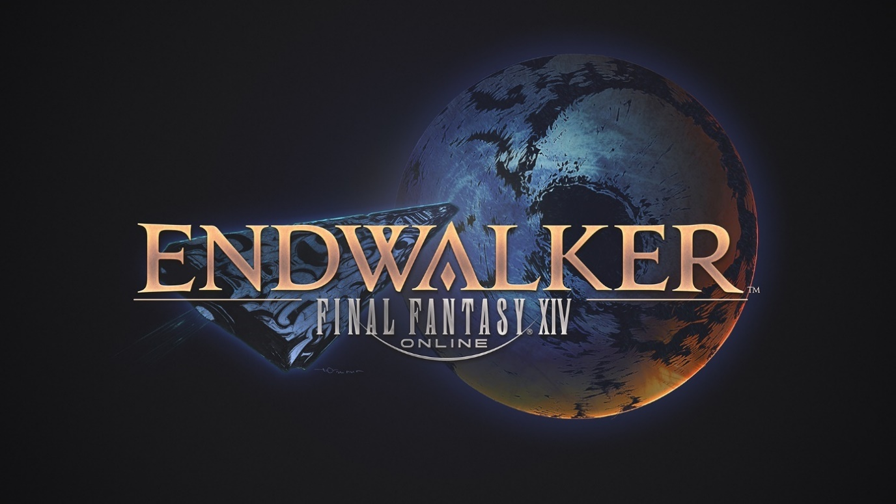

NEW MERCHANDISE COLLABORATIONS, ART BOOKS AND ROADMAP TO ENDWALKER REVEALED AT FINAL FANTASY XIV DIGITAL FAN FESTIVAL 2021

Fender and Citizen Watch Collaborations Detailed Alongside Patch 5.55 Release Date

LONDON (17th May, 2021) – SQUARE ENIX® unveiled new information on Patch 5.55 for FINAL FANTASY® XIV Online ahead of the release of Endwalker™, the highly anticipated fourth expansion pack for the award-winning MMO.

During Saturday’s Letter from the Producer LIVE stream, Producer and Director Naoki Yoshida outlined new content fans can expect from Patch 5.55 and beyond as FINAL FANTASY XIV: Shadowbringers comes to an end.

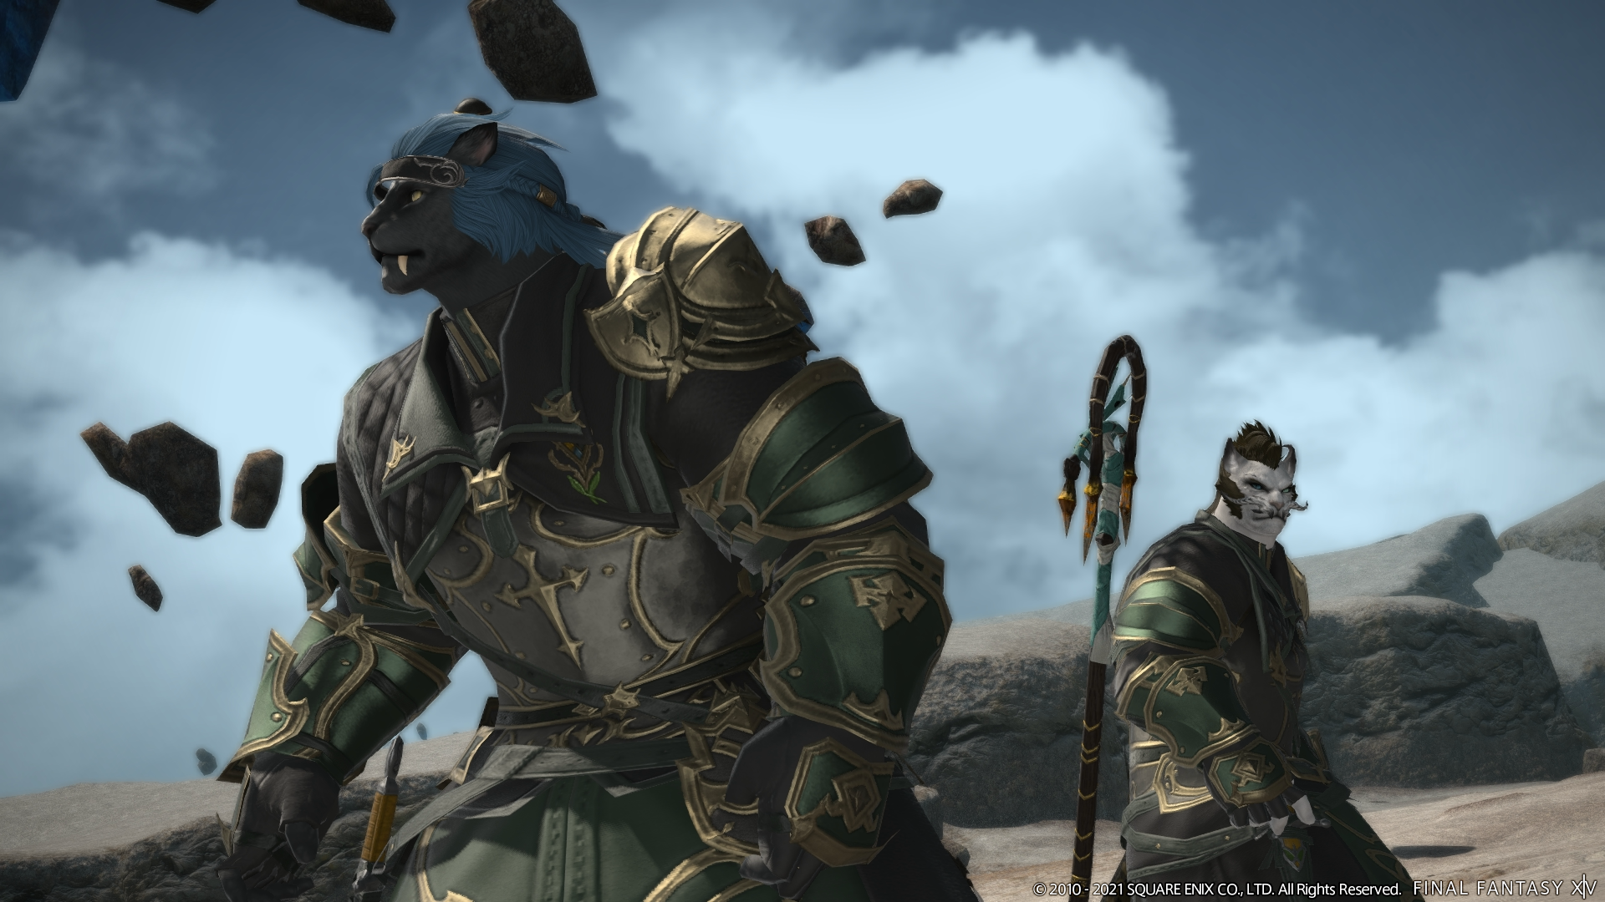

Patch 5.55 will launch on 25th May, bringing additions to the main scenario questline, YoRHa: Dark Apocalypse and Save the Queen questlines, as well as marking the start of official service for the PlayStation®5 version following an open beta period.

Yoshida also outlined the upcoming special event calendar, which includes the Make It Rain in-game event in July, the Moonfire Faire and The Rising in-game events in August, and a return of the FINAL FANTASY XV collaboration in September.

Further Patch 5.55 details outlined during the livestream can be found below:

- Patch 5.5 Main Scenario, Part II – The second part of this final main scenario update before Endwalker sets the stage for the upcoming expansion in grand fashion.
- YoRHa: Dark Apocalypse – Additional YoRHa: Dark Apocalypse story has been added to this epic crossover questline.
- “Save the Queen” Questline Update – This latest update includes a new field area, “Zadnor,” an increased resistance rank cap of 25, final enhancement of resistance weapons, and new large-scale battle content Dalriada for up to 48 players.

In addition, SQUARE ENIX announced collaborations with guitar powerhouse Fender Musical Instruments Corporation (“Fender”) and CITIZEN to create premium, FINAL FANTASY XIV-themed goods for fans to enjoy, as well as the upcoming release of FINAL FANTASY XIV: Shadowbringers -- The Art of Reflection -Histories Unwritten-, the second art book for the critically acclaimed expansion pack.

Debuted during the Letter from the Producer LIVE at FINAL FANTASY XIV Digital Fan Festival 2021, electric guitar manufacturer Fender has created a limited run of FINAL FANTASY XIV STRATOCASTER® guitars, featuring imitation crystal detailing, custom branding on the neck, and a custom, vintage-style hard shell case adorned with the FINAL FANTASY XIV logo. Fender will begin to take pre-orders for the FINAL FANTASY XIV STRATOCASTER® guitars in the Americas, EMEA and Australia in late 2021 and ship in early 2022.

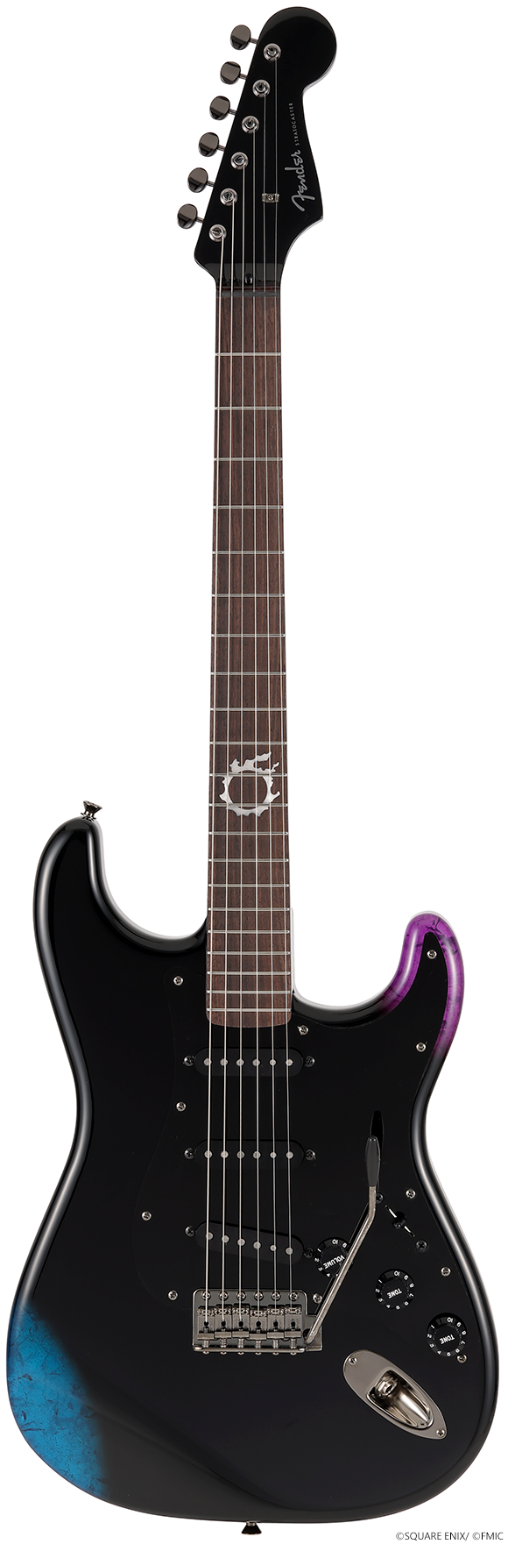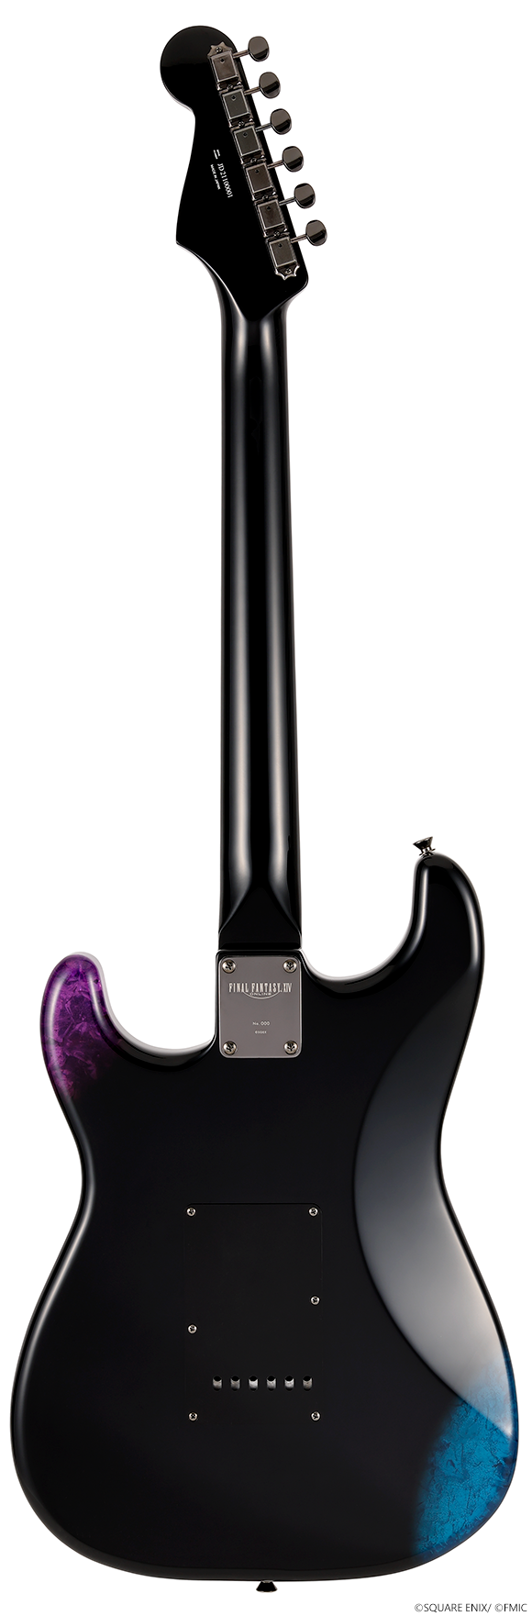

Players can also look forward to the electric guitar's addition in-game as the newest instrument for performance actions. The in-game model is inspired by the FINAL FANTASY XIV STRATOCASTER guitar and will feature the ability to switch between five different audio tones, including clean and distorted sounds. Additionally, players can also enjoy special performance features for the guitar including pick slide and mute effects. Furthermore, a new indoor furnishing—the Magitek Electric Guitar—designed after the FINAL FANTASY XIV version of the Stratocaster®, will be available to purchase in the Manderville Gold Saucer.

CITIZEN is also working in collaboration with SQUARE ENIX to create two FINAL FANTASY XIV-themed watches—named the LIGHT and DARKNESS models—inspired by a crystal of light and the Warriors of Darkness, respectively. Designed under the full supervision of the FINAL FANTASY XIV development team, both models have simple, classic designs suitable for any occasion and let owners feel connected to the FINAL FANTASY XIV universe as they go about their day. These new models will be available for pre-order on the SQUARE ENIX Store from today until Wednesday 30th June at 3:59pm BST in both LIGHT and DARKNESS varieties.

In addition, the company announced the upcoming release of FINAL FANTASY XIV: Shadowbringers -- The Art of Reflection -Histories Unwritten-, the second art book for the MMO’s critically acclaimed expansion pack. Now available for pre-order from the Square Enix Store and book retailers, this deluxe, large-format volume showcases artwork from YoRHa: Dark Apocalypse and the Eden raid series, as well as concept art of characters, environments, and more. The art book will also include a bonus code to redeem an in-game “Wind-up Runar'' minion.

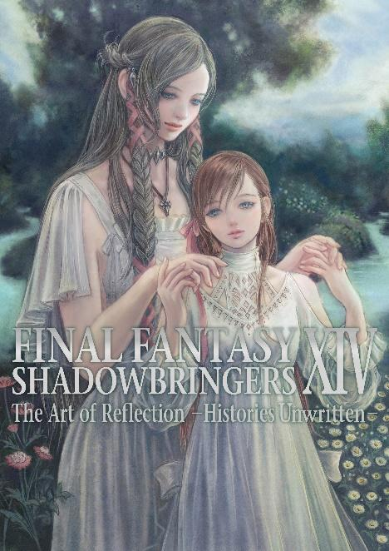

The book is available for pre-order on the Square Enix Store, alongside a variety of new items debuted in celebration of Final Fantasy XIV Digital Fan Festival 2021, including character figures, a set of Ascian-themed wine glasses, jewellery, a series of job icon-patterned accessories, and more: https://sqex.to/ShmwF

Final Fantasy XIV: A Realm Reborn -- The Art of Eorzea -Another Dawn- will also be republished as a new, physical edition, scheduled for release on 8th February, 2022. The physical edition of this book will include a bonus code to redeem an in-game “Wind-up Enterprise” minion, and is available for pre-order: https://sqex.to/esC20

Furthermore, six previously released artbooks have been confirmed for digital release by Square Enix Manga & Books imprints:

- Final Fantasy XIV: A Realm Reborn -- The Art of Eorzea - Another Dawn -
- Final Fantasy XIV: Heavensward -- The Art of Ishgard - Stone & Steel -
- Final Fantasy XIV: Heavensward -- The Art of Ishgard -Scars of War -
- Final Fantasy XIV: Stormblood -- Art of the Revolution - Western Memories -
- Final Fantasy XIV: Stormblood -- Art of the Revolution - Eastern Memories -
- Final Fantasy XIV: Shadowbringers -- The Art of Reflection - Histories Forsaken -

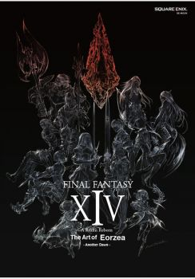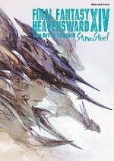

Players will now be able to enjoy the art of FINAL FANTASY XIV Online digitally, with e-book editions* becoming available for purchase from book retailers beginning 8th February, 2022.

*Digital editions of the art book will not include in-game item bonus codes.

The recently announced fourth expansion pack of the FINAL FANTASY XIV Online saga, Endwalker, is scheduled to release 23rd November, 2021 for PC, Mac, the PlayStation®5 system, and the PlayStation®4 system. Endwalker is the culmination of the Hydaelyn and Zodiark story, in which Warriors of Light will encounter an even greater calamity than ever before, and will bring an abundance of new content, including multiple new jobs, an increased level cap, vast new areas, adjustments to the battle system, as well as a variety of new battle, crafter and gatherer content.

FINAL FANTASY XIV: Endwalker’s full trailer can be found here: https://youtu.be/I4uwkvxsUac

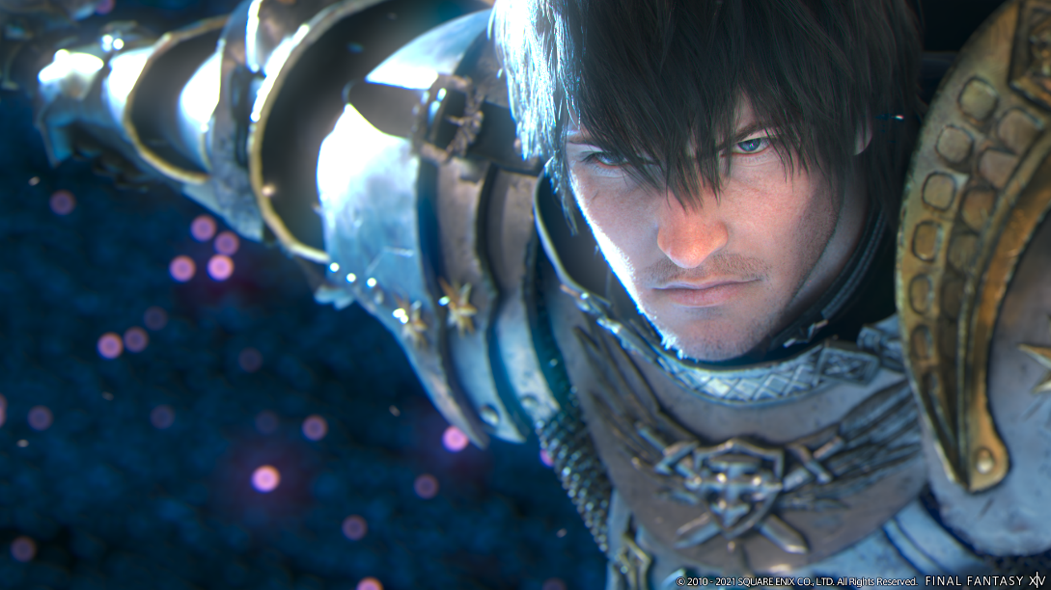

Visit the official FINAL FANTASY XIV: Endwalker site here:
https://eu.finalfantasyxiv.com/endwalker/

With over 22 million total registered players and a new expansion on the way, there has never been a better time for newcomers to begin their adventures in the critically acclaimed FINAL FANTASY XIV Online saga. The expanded Free Trial now includes all content from A Realm Reborn and the Heavensward™ expansion (and updates through Patch 3.56), as well as an additional playable race (Au Ra), and three additional playable jobs (Dark Knight, Astrologian, and Machinist). Free Trial players can enjoy hundreds of hours of award-winning gameplay and story experiences equivalent to two full FINAL FANTASY titles, without limit on playtime.

Related Links
Endwalker Teaser Site: http://eu.finalfantasyxiv.com/endwalker/
SQUARE ENIX® Press Site: https://www.square-enix-press.com/
The Lodestone®: http://eu.finalfantasyxiv.com
Official Facebook®: https://www.facebook.com/FinalFantasyXIV
Official Twitter®: @FF_XIV_EN
Official Instagram®: @ffxiv
#FFXIV

About Square Enix Ltd.
Square Enix Ltd. develops, publishes, distributes and licenses SQUARE ENIX®, EIDOS® and TAITO® branded entertainment content in Europe and other PAL territories as part of the Square Enix group of companies. Square Enix Ltd. also has a global network of leading development studios such as Crystal Dynamics® and Eidos Montréal. The Square Enix group of companies boasts a valuable portfolio of intellectual property including: FINAL FANTASY®, which has sold over 161 million units worldwide; DRAGON QUEST®, which has sold over 82 million units worldwide; TOMB RAIDER®, which has sold over 82 million units worldwide; and the legendary SPACE INVADERS®. Square Enix Ltd. is a London-based, wholly-owned subsidiary of Square Enix Holdings Co., Ltd.

ABOUT FENDER MUSICAL INSTRUMENTS CORPORATION:
Since 1946, Fender has revolutionized music and culture as one of the world’s leading musical instrument manufacturers, marketers and distributors. Fender Musical Instruments Corporation (Fender)–whose portfolio of owned and licensed brands includes Fender®, Squier®, Gretsch® guitars, Jackson®, EVH®, Charvel® and Bigsby®–follows a player-centric approach to crafting the highest-quality instruments and digital experiences across genres. Since 2015, Fender’s digital arm has introduced a new ecosystem of products and interactive experiences to accompany players at every stage of their musical journey. This includes innovative apps and learning platforms designed to complement Fender guitars, amplifiers, effects pedals, accessories and pro-audio gear, and inspire players through an immersive musical experience. Fender is dedicated to unlocking the power of musical expression for all players, from beginners to history-making legends. In 2021, Fender celebrates 75 years of giving artists "wings to fly," carrying on the vision of its founder, Leo Fender, and connecting players through a shared love of music.

ABOUT FENDER MUSIC CO. LTD:
Fender Music Co., Ltd. is the Japanese subsidiary and APAC Headquarters of FENDER MUSICAL INSTRUMENTS CORPORATION, a global guitar and amplifier production company founded in 1946. Since its establishment in April 2015, the company has been engaged in the sales, promotion, quality control, and customer support of FENDER®'s flagship guitar and bass products, TELECASTER®, STRATOCASTER®, PRECISION BASS®, JAZZ BASS®, as well as the TWIN REVERB, amplifiers, audio equipment, and lifestyle goods in the Japanese and Asian markets. We aim to be a “brand that supports all players” and support everyone who loves music. http://fender.co.jp

About CITIZEN WATCH
CITIZEN WATCH is a true manufacture d'horlogerie with a comprehensive manufacturing process that extends from creating a watch’s individual components to its final assembly. The company operates in more than 140 countries and regions around the world. Since its founding in 1918, CITIZEN has held the belief of “Better Starts Now” — that is, no matter who you are and what you do, it is always possible to make something better, and now is the time to start doing it. Based this belief, we have created watches, invented and improved technologies and explored the future of watches such as our proprietary light-powered Eco-Drive technology and state-of-the-art satellite-synchronized timekeeping
*The final design and specifications are subject to change without notice.

FINAL FANTASY XIV © 2010 - 2021 SQUARE ENIX CO., LTD. All Rights Reserved.
FINAL FANTASY XIV: ENDWALKER © 2021 SQUARE ENIX CO., LTD. All Rights Reserved.
LOGO ILLUSTRATION: ©2021 YOSHITAKA AMANO
ENDWALKER, SHADOWBRINGERS, the FINAL FANTASY XIV logo, CRYSTAL DYNAMICS, DRAGON QUEST, EIDOS, EIDOS MONTREAL, EORZEA, FINAL FANTASY, the FINAL FANTASY logo, THE LODESTONE, SPACE INVADERS, SQUARE ENIX, the SQUARE ENIX logo, TAITO and TOMB RAIDER are registered trademarks or trademarks of the Square Enix group of companies. “PlayStation" and the "PS" Family logo are registered trademarks and "PS4" and “PS5” are trademarks of Sony Interactive Entertainment Inc. FENDER, STRATOCASTER and the distinctive headstock shapes of the Fender Stratocaster guitars are trademarks of Fender Musical Instruments Corporation and/or its affiliates, registered in the U.S. and other countries. Eco-Drive is registered trademarks or trademarks of Citizen Watch Co., Ltd. All other trademarks are properties of their respective owners.

###
Contact (press only):
Luke Karmali
Square Enix, Ltd.
+44 (0) 7813 374414
LukeK@eu.square-enix.com

