FOR IMMEDIATE RELEASE
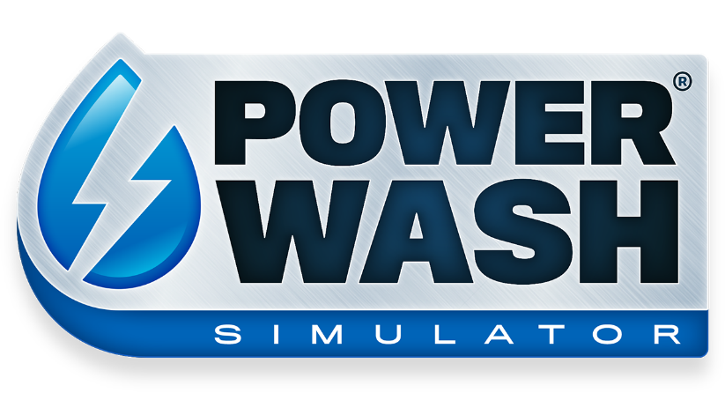
POWERWASH AND CHILL WITH POWERWASH SIMULATOR ONLINE CO-OP OUT NOW!
PLAY ONLINE CO-OP WITH UP TO 6 FRIENDS IN POWERWASH SIMULATOR’S LATEST UPDATE ON STEAM EARLY ACCESS.

LONDON (December 2nd 2021) – Today, boutique studio FuturLab released their latest update for Steam Early Access title POWERWASH SIMULATOR with Square Enix Collective. Published by Square Enix Ltd, the newest update features Online Co-Op, new Career Jobs, new Challenges and the highly anticipated Professional Duty Washer!

In the newest update, PowerWash and chill in Online Co-Op! Lend a helping hand to your closest pal in Career Mode or up to 6 friends can splash around in Free Play, tackling any job the host has already completed. We also have brand new Career Mode jobs; freshen up the feline features of the Mayor's Monster Truck, then clean and ride on the Ferris Wheel down at the Fairground.

"Online Co-Op is a big step toward the vision we have for this game, and is one of our most requested community features, so we can't wait to see the reaction," commented James Marsden, FuturLab Founder and Creative Director. "Co-op brings people together, allowing players to enjoy the game with their friends, in a relaxing non-competitive environment."

That's not all for this update! We have more cool cosmetics to make the game your own, including gloves, washer skins and new character skins.

On top of all that, the most powerful power washer class ever has arrived! The Professional Duty Washer will make light work of previous dirt tiers, but watch out for new, oily dirt types mucking up the town. For a complete list of what's new, check out our patch notes on Steam.

POWERWASH SIMULATOR lets players wash away their worries with the soothing sounds of high-pressure water. Players can build their very own power washing business and blast away every speck of dirt and grime they can find. With a unique take on the simulation genre, POWERWASH SIMULATOR focuses on player relaxation and escapism.

POWERWASH SIMULATOR is currently available on Steam Early Access here: http://bit.ly/PWSOutNowSteam

Press contact Futurlab: press@futurlab.co.uk
Press contact Square Enix Collective: collective-pr@eu.square-enix.com
Related Links:
PowerWash Simulator Co-Op Trailer:
Press Kit:
Official Website: https://futurlab.co.uk/game/powerwash-simulator-2/
Steam Early Access: http://bit.ly/PWSOutNowSteam
Twitter: @PowerWashSim
Discord: https://bit.ly/JoinPWSDiscord
TikTok: @powerwashsim
YouTube: http://bit.ly/FuturLabYT
Instagram: https://www.instagram.com/powerwashsim/
About FuturLab
FuturLab is a boutique, award-winning game studio based in Brighton, UK. FuturLab has developed and published remarkable games on PC and console since 2003. The game studio is best known for Velocity 2X, Tiny Trax, Mini-Mech Mayhem and Peaky Blinders: Mastermind and is currently working on the highly anticipated PowerWash Simulator.

About Square Enix Collective
Square Enix Collective® is a London-based division of Square Enix Ltd. The Collective programme was launched in 2014 to assist indie game developers build community awareness for hundreds of games pitches and has helped teams to raise in excess of $1.2 million via Kickstarter campaigns. Collective has now published and distributed a range of indie titles since April 2016 and is on the look-out for great new projects and talented teams to work with globally – whether it’s publishing support for a development that’s already funded, or investment to help the creation of a game.

About Square Enix Ltd.
Square Enix Ltd. develops, publishes, distributes and licenses SQUARE ENIX®, EIDOS® and TAITO® branded entertainment content in Europe and other PAL territories as part of the Square Enix group of companies. Square Enix Ltd. also has a global network of leading development studios such as Crystal Dynamics® and Eidos Montréal®. The Square Enix group of companies boasts a valuable portfolio of intellectual property including: FINAL FANTASY, which has sold over 161 million units worldwide; DRAGON QUEST®, which has sold over 82 million units worldwide; TOMB RAIDER®, which has sold over 82 million units worldwide; and the legendary SPACE INVADERS®. Square Enix Ltd. is a London-based, wholly owned subsidiary of Square Enix Holdings Co., Ltd.

More information on Square Enix Ltd. can be found at https://square-enix-games.com.
##
CRYSTAL DYNAMICS, DRAGON QUEST, EIDOS, EIDOS MONTREAL, FINAL FANTASY, SPACE INVADERS, SQUARE ENIX, the SQUARE ENIX logo, TAITO and TOMB RAIDER are registered trademarks or trademarks of the Square Enix group of companies. All other trademarks are properties of their respective owners.

