FOR IMMEDIATE RELEASE

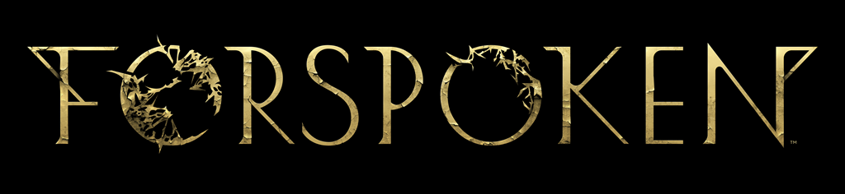

SQUARE ENIX AND LUMINOUS PRODUCTIONS’ FORSPOKEN CONFIRMED FOR RELEASE
ON MAY 24, 2022
Actor Pollyanna McIntosh Revealed as the Voice Actor for Tanta Prav;
Pre-Orders Available Now on PlayStation®5 and PC
LONDON (Dec. 10, 2021) – Today at The Game Awards, SQUARE ENIX® and Luminous Productions unveiled a new trailer for the studio’s debut title, Forspoken, announcing a worldwide release date of May 24, 2022. The trailer was introduced by Forspoken star Ella Balinska, who plays protagonist Frey Holland, and actor Pollyanna McIntosh (The Walking Dead series), who has joined the cast as the ruthless Tanta Prav.

To watch the new Forspoken | The Game Awards 2021 Trailer, visit: https://www.youtube.com/watch?v=bxrXDbU-S3k

In the new trailer, fans are given a closer look at the mysterious land of Athia and meet some of its last remaining citizens. Players also learn about the impending corruption called the “Break”: a devastating miasma that relentlessly corrupts everything it touches. Frey has somehow mysteriously survived this strange phenomenon, offering Athia a beacon of hope.

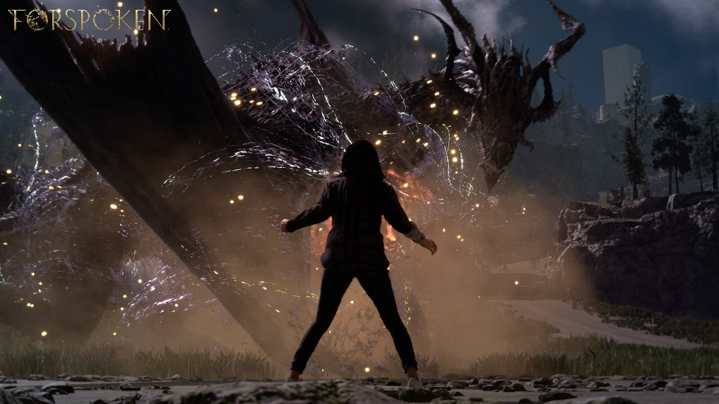

New action-packed gameplay featured in the trailer showcases how Frey’s quest in Athia will take her through a variety of diverse environments where she will learn how to use magic parkour to traverse across the unknown land in a fast and fluid manner, as well as her magic abilities to battle Athia’s dangerous beasts that she will encounter on her journey, including the newly revealed Breakzombies and Jabberwock.

Players were also introduced to a new character in Forspoken—the maddened evil sorceress, Tanta Prav—who is voiced and performed by The Walking Dead’s (TV Series) Pollyanna McIntosh. “It’s been wild playing Tanta Prav and I’m excited for players to meet her and experience her as Frey does: a remorseless, unrelenting powerhouse, full of secrets,” said McIntosh. “I think she will prove to be a ruthless adversary for players as they follow Frey on her journey in the land of Athia.”

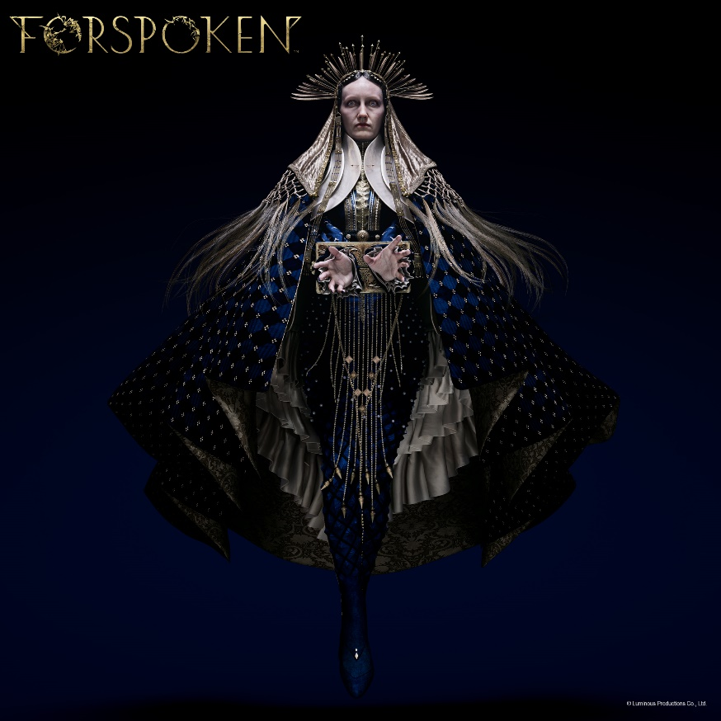

SQUARE ENIX and Luminous Productions also revealed details of the Digital Deluxe Edition, available to pre-order from today. The Digital Deluxe Edition contains several exciting bonuses, including:

- Rare Resource Kit (Only included for the PlayStation®5 console Digital Deluxe Edition)
- Mini Artbook (Digital Download)
- Mini Soundtrack (Digital Download)
- Forspoken: In Tanta We Trust prequel story DLC*

Those who pre-order the Digital Deluxe Edition will also receive the below unique gear and items to aid them in their journey through Athia:

- No Limits Cloak, Symbol Combo Necklace, Trigger Happy Nails and Crafting Starter Kit (PS5)
- Elite Cloak, Spectra Combo Necklace and Overclock Nails (PC)

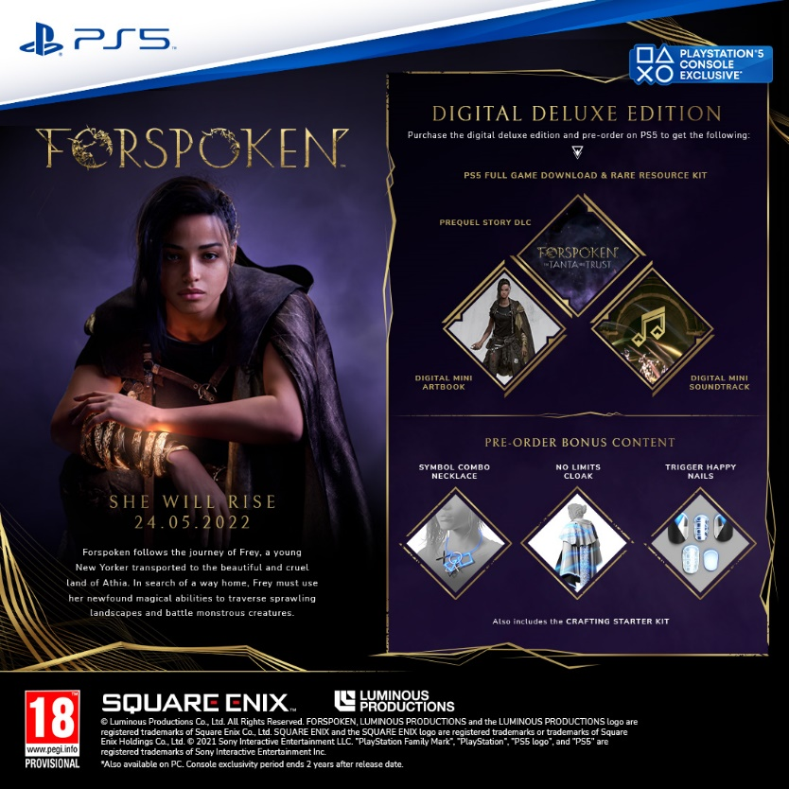
The Digital Standard Edition is also available to pre-order from today. Players who pre-order the digital standard edition for PS5 or PC (via STEAM®, Epic Games Store or Microsoft Store) will also receive the above pre-order bonus items for the respective platform at launch.

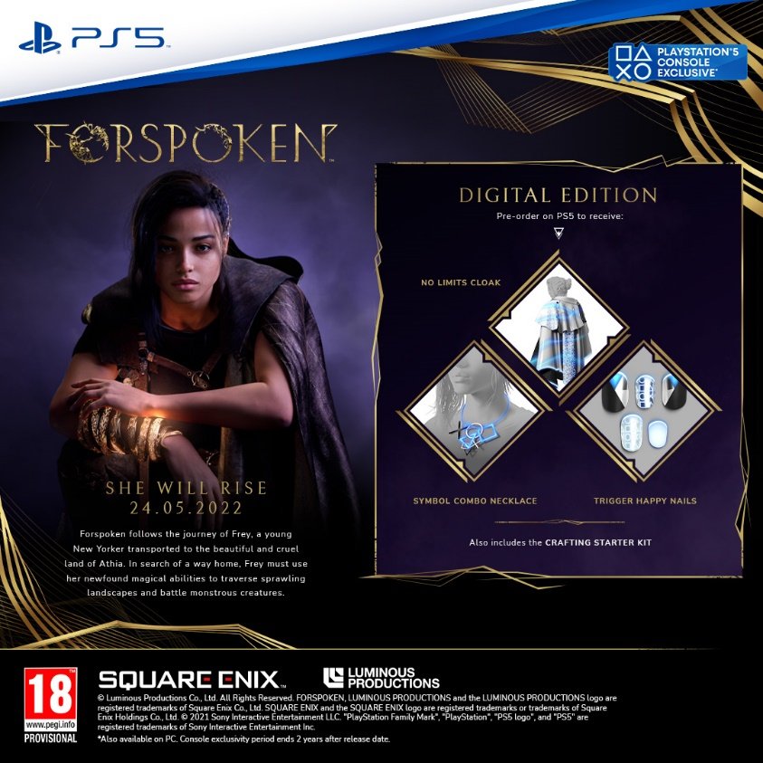
The physical (disc) version** of the game will also be available from participating retailers. Pre-orders of the physical (disc) version are subject to local retailer availability and schedule***.

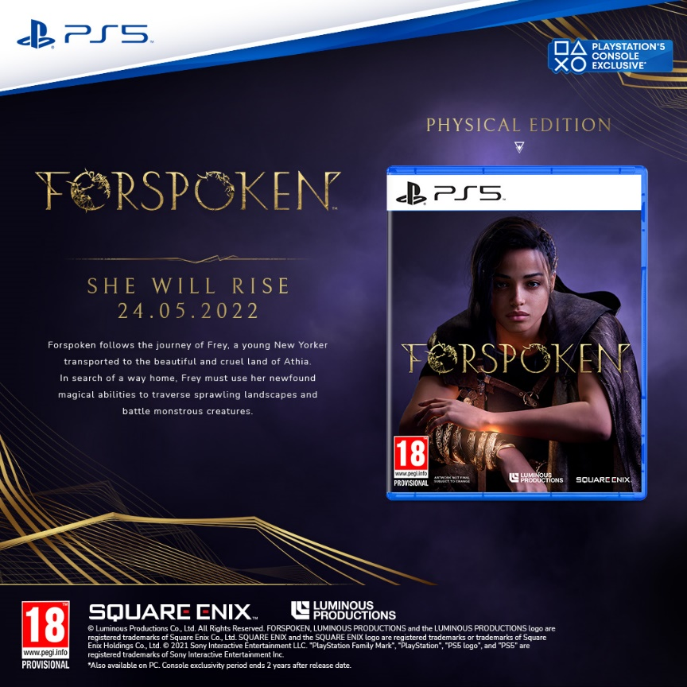
Designed for PS5, Forspoken will harness the full power of the console and demonstrate Luminous Productions’ philosophy to provide a gaming experience like never before, fusing together the latest technology with creativity. Forspoken will launch simultaneously on the PS5 and PC (via STEAM®, Epic Games Store or Microsoft Store) on May 24, 2022.

To learn more about Forspoken, visit: www.forspoken.com.

Related Links:
Forspoken Website: www.forspoken.com
Luminous Productions Website: https://www.luminous-productions.com
Facebook: www.facebook.com/Forspoken
Twitter: @Forspoken
Instagram: @Forspoken
#Forspoken

* Forspoken: In Tanta We Trust DLC coming Winter 2022, following the game’s launch. Players who pre-order the Digital Deluxe Edition will receive early access to this prequel story DLC when it becomes available.
** In-game digital pre-order bonus items not available by pre-ordering the physical version.
*** The start of pre-orders for the physical version will vary by retailer.

About Square Enix Ltd.
Square Enix Ltd. develops, publishes, distributes and licenses SQUARE ENIX®, EIDOS® and TAITO® branded entertainment content in Europe and other PAL territories as part of the Square Enix group of companies. Square Enix Ltd. Also has a global network of leading development studios such as Crystal Dynamics® and Eidos Montréa®. The Square Enix group of companies boasts a valuable portfolio of intellectual property including: FINAL FANTASY®, which has sold over 164 million units worldwide; DRAGON QUEST®, which has sold over 83 million units worldwide; TOMB RAIDER®, which has sold over 85 million units worldwide; and the legendary SPACE INVADERS®. Square Enix, Ltd. is a London-based, wholly owned subsidiary of Square Enix Holdings Co., Ltd.

More information on Square Enix Ltd. can be found at https://square-enix-games.com

# # #

© Luminous Productions Co., Ltd. All Rights Reserved
FORSPOKEN, LUMINOUS PRODUCTIONS, DRAGON QUEST, EIDOS, EIDOS MONTREAL, FINAL FANTASY, SPACE INVADERS, SQUARE ENIX, the SQUARE ENIX logo, TAITO and TOMB RAIDER are registered trademarks or trademarks of the Square Enix group of companies. “PlayStation” and “PS5” are a registered trademark or trademarks of Sony Interactive Entertainment Inc. All other trademarks are properties of their respective owners.

