FOR IMMEDIATE RELEASE

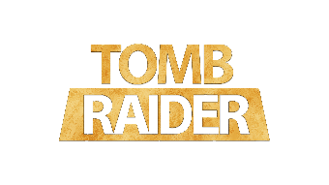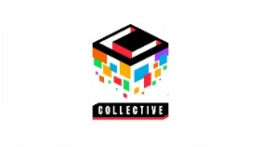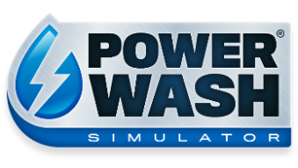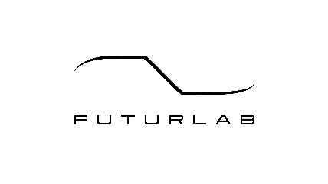

TOMB RAIDER’S CROFT MANOR LANDS IN POWERWASH SIMULATOR

Wash Lara Croft’s home back to its former glory with the soothing sounds of high-pressure water in the new Special Pack coming to the game

LONDON (JANUARY 18, 2023) – Square Enix Collective®, FuturLab, and Crystal Dynamics® announced today that a free TOMB RAIDER® Special Pack is coming to all POWERWASH SIMULATOR players on January 31. The super-soothing simulator is also set to launch on PlayStation®4 (PS4™), PlayStation®5 (PS5™) consoles and Nintendo Switch® on the same day.

Watch the TOMB RAIDER Special Pack announcement trailer here.

“Creating the TOMB RAIDER Special Pack has been an honour and a fantastic experience” said Dan Chequer, Lead Designer at FuturLab. “We can’t wait for players to get up close and personal with Croft Manor and explore its many secrets!”

“What Tomb Raider fan hasn’t explored Croft Manor and thought ‘Winston could really use some help with these grounds! I would love to power wash this place!’?” asked Dallas Dickinson, Franchise General Manager for TOMB RAIDER at Crystal Dynamics. “Now, with the help of Square Enix Collective and FuturLab that’s not only possible, but immensely satisfying as well.”

“We know the community wants more to clean, and I’m delighted we’re able to kick off our post-release plans in style with this TOMB RAIDER collaboration,” added Phil Elliott, studio head at Square Enix Collective®. “We’ve had so much great support from players, press and content creators, and we wanted to do something special to say thank you!”

POWERWASH SIMULATOR is currently available on Xbox Series X|S, Xbox One, PC via Steam® and Windows 10, and is available with Xbox Game Pass and PC Game Pass. POWERWASH SIMULATOR will launch on PlayStation®4 (PS4™), PlayStation®5 (PS5™) consoles and Nintendo Switch® on January 31.

For more information, visit: www.powerwashsimulator.com

Press contact FuturLab: press@futurlab.co.uk
Press contact Square Enix Collective: collective-pr@eu.square-enix.com
Press contact Crystal Dynamics/TOMB RAIDER: press@crystald.com
Related Links:
PowerWash Simulator:
Official Website: www.powerwashsimulator.com
Steam®: http://bit.ly/PWSOutNowSteam
Twitter: @PowerWashSim
Discord: https://bit.ly/JoinPWSDiscord
YouTube: http://bit.ly/FuturLabYT
Instagram: https://www.instagram.com/powerwashsim/
For More Information About TOMB RAIDER, Follow At:
Official Website: www.tombraider.com
Twitter: https://twitter.com/tombraider
Discord: https://discord.gg/tomb-raider
YouTube: https://www.youtube.com/tombraider
Instagram: https://www.instagram.com/tombraider/
Facebook: https://www.facebook.com/TombRaider/

About TOMB RAIDER
The TOMB RAIDER video game franchise, which recently celebrated its 25th anniversary, has sold over 95 million copies worldwide. The franchise’s popularity has exploded into a series of blockbuster films based on the original Tomb Raider game and 2013 reboot. Its protagonist Lara Croft has been a contemporary global icon for over two decades. The most-recent release in the world-famous franchise, Shadow of the Tomb Raider, received numerous “Best of” nominations and awards and is the remarkable conclusion to Lara Croft’s origin story. All of this continues to make TOMB RAIDER a destination brand for action-adventure.
TOMB RAIDER Related Links: Official Website, Twitter, Discord, YouTube, Instagram, Facebook
About Crystal Dynamics
Crystal Dynamics has developed and published more than 30 games during its award-winning, 30-year adventure. Some of the company’s beloved franchises include Legacy of Kain and TOMB RAIDER, which has sold more than 95 million copies worldwide. TOMB RAIDER’s protagonist, the hero Lara Croft, has been a cultural icon for more than 25 years, appearing in more than 20 games, and has made an indelible mark on virtually every facet of entertainment. In addition to its headquarters in San Mateo, California, Crystal Dynamics has two additional studios: Crystal Northwest in Bellevue, Washington, and Crystal Southwest in Austin, Texas.

Crystal Dynamics’ website can be found at https://crystald.com/

About FuturLab
FuturLab is a boutique, award-winning game studio based in Brighton, UK. FuturLab has developed and published remarkable games on PC and console since 2003. The game studio is best known for Velocity 2X, Tiny Trax, Mini-Mech Mayhem and Peaky Blinders: Mastermind and is currently working on the highly anticipated PowerWash Simulator.
About Square Enix Collective®
Square Enix Collective® is a London-based division of Square Enix Ltd. The Collective programme was launched in 2014 to assist indie game developers build community awareness for hundreds of games pitches and has helped teams to raise in excess of $1.2 million via Kickstarter campaigns. Collective has now published and distributed a range of indie titles since April 2016 and is on the look-out for great new projects and talented teams to work with globally – whether it’s publishing support for a development that’s already funded, or investment to help the creation of a game.

About Square Enix Ltd.
Square Enix Ltd. develops, publishes, distributes, and licenses SQUARE ENIX® and TAITO® branded entertainment content in Europe and other PAL territories as part of the Square Enix group of companies. The Square Enix group of companies boasts a valuable portfolio of intellectual property including FINAL FANTASY®, which has sold over 173 million units worldwide; DRAGON QUEST®, which has sold over 85 million units worldwide; and the legendary SPACE INVADERS®. Square Enix Ltd. is a London-based, wholly owned subsidiary of Square Enix Holdings Co., Ltd.

More information on Square Enix Ltd. can be found at https://square-enix-games.com/"About Square Enix Holdings Co., Ltd.##

POWERWASH SIMULATOR © 2021, 2022, 2023 FuturLab Limited. All Rights Reserved.
POWERWASH SIMULATOR logo is a registered trademark of FuturLab Limited. DRAGON QUEST, SPACE INVADERS, TAITO, SQUARE ENIX, the SQUARE ENIX logo, SQUARE ENIX COLLECTIVE, and the SQUARE ENIX COLLECTIVE logo are registered trademarks or trademarks of Square Enix group of companies. CRYSTAL DYNAMICS, CRYSTAL NORTHWEST, CRYSTAL SOUTHWEST, TOMB RAIDER, LARA CROFT, and LEGACY OF KAIN are registered trademarks or trademarks of the Crystal Dynamics group of companies. “STEAM” and Steam logo are trademarks and/or registered trademarks of Valve Corporation in the U.S. and/or other countries. “PlayStation” and “PS5” are a registered trademark or trademarks of Sony Interactive Entertainment Inc. “Nintendo Switch” is a trademark of Nintendo Co., Ltd. All other trademarks are properties of their respective owners

